**Problem of the Week # 3**

**Repeating Pattern**

Here is the core* of a repeating pattern. The core contains these 5 objects (or terms) and then it repeats. 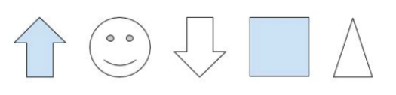

Answer Question 1 or all questions.

Question 1: What would be the 15th object in this pattern?

Question 2: What would be the 28th object in this pattern?

Question 3: What would be the 101st object in this pattern?

**Show your work using pictures, words, or numbers.**

*\*Note: The part of a repeating pattern, that stays the same and repeats itself, is called its* ***core.***